SEVeros Feature Matching System
In the technologically advanced city of Severos, the students of Millennia Science School are developing a new object detection system capable of identifying and tracking targets in complex, real world environments by combining advanced feature detection and feature matching techniques, allowing it to remain accurate despite variations in angle, motion, and lighting; to ensure its robustness, they train and evaluate the system using datasets composed of familiar student faces from multiple academies across Severos, simulating realistic and dynamic scenarios. Final output of the program is to display the most similar match for any detected face based on feature correspondence
- Dataset Description
The datasets consist of:
- Target Object Image
A reference image representing the object or face to be detected.
- Student Images
A collection of images containing several Severos students used as candidates for matching.

- Dataset Preprocessing
All images, target and object, need preprocessing steps such as grayscale conversion and blur filter to reduce noise and ensure consistency of feature extraction and matching. You can use Gaussian Blur with the following specifications:
- Kernel size width: 3
- Kernel size height: 3
- SigmaX: 0

- Feature Detection
In this stage, several feature detection methods such as SIFT, AKAZE, and ORB are used to extract keypoints and descriptors, with particular attention to the fact that each method may produce different descriptor data types (e.g., floating-point or binary), which must be properly converted to ensure compatibility with the FLANN.

- Feature Matching
The target object image will be matched with pictures from the object images using the FLANN algorithm. Matching keypoints are filtered using Lowe’s Ratio Test to eliminate unreliable correspondences, and different Lowe’s ratio keypoints are evaluated to determine the best match result. The final output should be displayed in color (RGB) and include all the lines representing the matching keypoints.
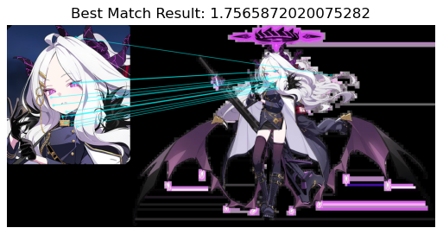
Figure 1. Best Match Result

